# SamBot Specification

# Software System Requirements

# Introduction

A two-wheels robot needs to be designed in order to roll and detect obstacles and void in front of it.

This document lists all the system requirements.

Every requirement is composed of:

* One unique ID following this pattern: SYS_XXXX (Four digits),
* A name, which is always a small introduction of the requirement,
* A text, describing what is this requirement for.

## SYS_0100

Name: Autonomous bot

Text: The SamBot shall communicate without physical connection with a computer terminal.

## SYS_0200

Name: Obstacle detection

Text: SamBot shall detect obstacles in front of it.

## SYS_0300

Name: void detection

Text: The SamBot shall detects void in front of it.

## SYS_0400

Name: Debug mode

Text: The SamBot shall provide debug value to the computer on demand.

## SYS_0500

Name: Manual Mode

Text: The SamBot shall follow instructions from the computer in Manual Mode

## SYS_0600

Name: Autonomous Mode

Text: The SamBot shall roll and avoid obstacles by its own in Autonomous Mode

## SYS_0700

Name: User interface

Text: The SamBot shall provide an easy-use interface through the terminal

## SYS_0800

Name: Movement

Text: The SamBot shall be able to move around its environment

# Software Architectural Design Requirements

A two-wheels robot needs to be designed in order to roll and detect obstacles and void in front of it.

This document lists the requirements of the software and the hardware architectural design.

Every requirement is composed of:

* One unique ID following this pattern: ADR_XXXX (Four digits)
* A name, which is always a small introduction of the requirement
* A text, describing what is the requirement for.

Here is the schematic of the system:

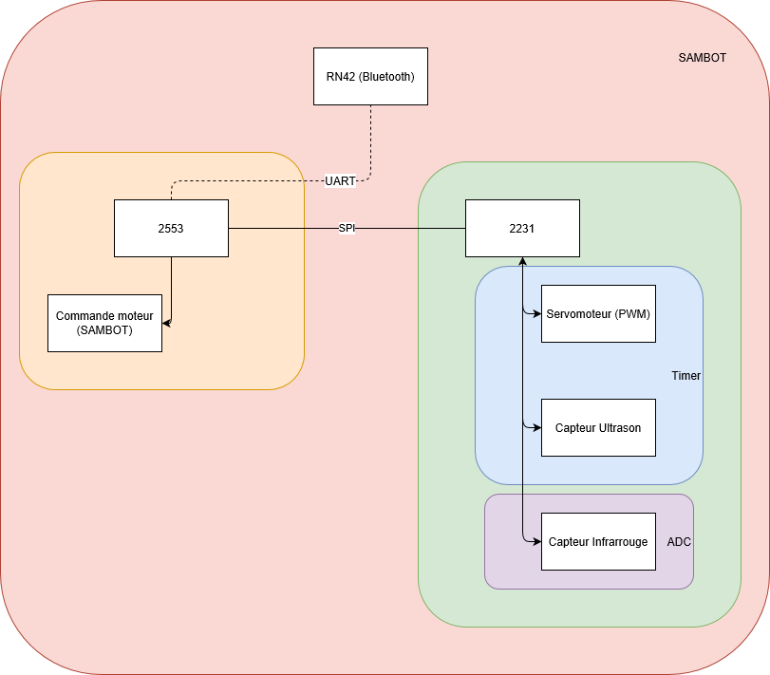

## ADR_0100

Name: Roll

Text: The robot shall roll in a reasonable speed.

Covers: Sys_0500, Sys_0600

Module: Movement

## ADR_0200

Name: Obstacle detection

Text: The robot shall detect obstacles in front of it with an ultrasound sensor.

Covers: Sys_0200

Module: Obstacle_Detection

## ADR_0250

Name: Obstacle reaction

Text: When an obstacle has been detected, the robot shall stop and turn right before running forward.

Covers: Sys_0200

Module: Obstacle_Detection

## ADR_0300

Name: ultrasound sensor

Text: The sensor will be placed on a servomoteur that will move within a 180° area

Covers: Sys_0200

Module: Obstacle_Detection

## ADR_0400

Name: Void detection

Text: The robot shall detect a void in front of it with an infrared sensor.

Covers: Sys_0300

Module: Void_Detection

## ADR_0450

Name: Void reaction

Text: When a void has been detected, the robot shall stop, run backward for a few inches and turn around before running forward.

Covers: Sys_0300

Module: Void_Detection

## ADR_500

Name: infrared sensor

Text: the infrared sensor will be placed at the edge of the robot in order to detect the void early

Covers: Sys_0300

Module: Void_Detection

## ADR_0600

Name: Manual mode

Text: The user shall be able to control the robot by sending commands to it via the MSP2553 with a UART connection (Bluetooth), from a terminal of a computer.

Covers: Sys_0500

Module: ManualMode

## ADR_0700

Name: Autonomous mode

Text: the robot shall be able to manage itself without the intervention of the user

Covers: Sys_0600

Module:AutoMode

## ADR_0800

Name: Communication

Text: The robot shall communicate with the user with a UART connection via Bluetooth

Covers: Sys_0100

Module: Com

## ADR_0900

Name: Structure

Text: the robot shall have two processors:

MSP2553, which controls robot’s motors (direction). It receives the user’s commands via and sends the commands to the second processor

MSP2231, which receives the commands via SPI connection and handles the servomoteur and the two sensors (ultrasound and infrared)

Covers: all

Module:

## ADR_1000

Name: Turn around

Text: The robot shall be able to turn left, turn right, run forward and backward  
Covers: Sys_0800

Module: Movement

## ADR_1100

Name: Help

Text: When the user enters a wrong command, the robot shall display the help assistance.

Covers: Sys_0700

Module: Help

## ADR_1200

Name: Debug mode

Text: the debug mode shall display the measures of all the sensors on real time when the user demands it.

Covers: Sys_0400

Module: Debug

# Software Detailed Design Requirements

# Introduction

A two-wheels robot needs to be designed in order to roll and detect obstacles and void in front of it.

This document lists the requirementsof the software and hardware detailed design.

Every requirement is composed of:

* One unique ID following this pattern: DDR_XXXXX (Five digits),
* A name, which is always a small introduction of the requirement,

A text, describing what is this requirement for.

## DDR_00100

Name: Turning right

Text: If the user writes “d” in the terminal, The SamBot shall turn 90° right.

Cover: ADR_0900

Function: Turn_Right

## DDR_00200

Name: Turning left

Text: If the user writes “q” in the terminal, The SamBot shall turn 90° left.

Cover: ADR_0900

Function: Turn_Left

## DDR_00300

Name: Run forward

Text: If the user writes “z” in the terminal, The SamBot shall run forward.

Cover: ADR_0900

Function: Run_Forward

## DDR_00400

Name: Run backward

Text: If the user writes “s” in the terminal, The SamBot shall run backward.

Cover: ADR_0900

Function: Run_Backward

## DDR_00500

Name: Change to manual mode

Text: If the user writes “M” in the terminal, the state of the machine shall change to Manual Mode.

Covers: ADR_0500

Function: Main

## DDR_00600

Name: Change to Autonomous mode

Text: If the user writes “A” in the terminal, the state of the machine shall change in Autonomous Mode.

Covers: ADR_0600

Function: Main

## DDR_00700

Name: cycle Autonomous

Text: When the SamBot is in autonomous mode, it shall alternatively move forward a little and get sensors information.

Covers: ADR_0600, ADR_0400, ADR_0200

Function: Auto_drive

## DDR_00800

Name: User input help

Text: If the Sambot receives any input not defined in the menu then it shall invoke UI_help to guide the user

Covers: ADR_1100

Function: interpreter

## DDR_00900

Name: Debug mode

Text: If the user writes “B” in the terminal, it shall display the measures of all the sensors in real time.

Covers: ADR_1200

Function: Debug

## DDR_01000

Name: Manual Mode

Text: In manual mode, the MSP2231 shall continue to send the sensors’ information to the MSP2553, but the microcontroller shall ignore them.

Covers: ADR_0600

Function: Manual_mode

## DDR_01100

Name: Sending information

Text: the MSP2231 shall always send the sensors’ information to the MSP2553

Covers: ADR_0300, ADR_0500

Function: Sensors

## DDR_01200

Name: Void detection

Text: the MSP2553 shall command the robot to stop, run backward and turn around if the value received from the infrared sensor (sent by the MSP2231) indicates a void.

Covers: ADR_0400, ADR_0450

Function: Void_detection

## DDR_01300

Name: Obstacle detection

Text: the MSP2553 shall command the robot to stop and turn right if the value received from the ultrasound sensor (sent by the MSP2231) indicates an obstacle.

Covers: ADR_0200, ADR_0250

Function: Obstacle_Detection

## DDR_

Name:

Text:

Covers:

Function:

## DDR_

Name:

Text:

Covers:

Function:

## DDR_

Name:

Text:

Covers:

Function: